Maker-Breaker Triangle Game
Chandranshu Gautam¹ and C. Patvardhan¹
¹Department of Electrical Engineering, Dayalbagh Educational Institute,
Dayalbagh, Agra, 282005, Uttar Pradesh, India.
chandranshu191200@dei.ac.in and cpatvardhan@dei.ac.in

Abstract—The Maker-Breaker triangle game, introduced by Chvátal and Erdős (1978), is a two-player mathematical combinatorial game that involves creating and restricting the formation of triangles on a complete graph. For n,q ∈ N, the (n,q)-triangle game is played by two players- Maker and Breaker, on a complete graph K_{n} , where n is the number of nodes and q is the number of moves for Breaker in each chance. Alternately, Maker chooses one vertex/edge and thereafter Breaker chooses q vertices/edges. The objective of the Maker is to complete a triangle consisting of his/her choices whereas the Breaker needs to stop the same. The Maker wins the game if he claims all the edges/nodes of a triangle otherwise the breaker wins. The game requires strategic thinking and mathematical skills, as players must analyze the graph and anticipate their opponent's moves in order to respond effectively.
In this paper, we present a Maker-Breaker triangle game simulator in the form of a web-based application. The simulator generates randomized game scenarios with provision for increasing the level of challenge and excitement for the players by varying q. The simulator facilitates two-person game play as well as one person game play with computer playing the Breaker and the person as the Maker. It is well-known that the choice of q results in three possible outcomes with theoretical bounds on q. Maker wins for smaller q’s, Breaker for larger q’s and a region of uncertainty in between. The experience with the simulator is envisaged to provide intuition for further improving the theoretical bounds on winning ranges of q for Maker and Breaker. It can also facilitate generalizing the game for any graph rather than complete graphs.
Keywords—Maker, Breaker, Triangle Game, Complete Graphs, Edges, Nodes, Strategy, Game Theory, Algorithm.

Introduction
Games are a novel and distinctive way of conveying complex concepts and ideas to students. Games are designed to engage players in a playful and interactive way, while at the same time developing their thinking skills and understanding. Specially, Mathematical games are an effective tool for conveying complex concepts and ideas. Through mathematical games, complex mathematical concepts such as logic, geometry, algebra, probability, and number theory can be presented in an enjoyable and engaging way. For example, games like Sudoku, Tic-Tac-Toe, Kakuro, and KenKen require players to use logical reasoning and critical thinking to solve mathematical puzzles, while games like Tetris require players to use spatial reasoning and geometry to manipulate shapes and patterns.
"Maker-Breaker" games are puzzle games where players must use logical reasoning to reach a specific goal. The games involve creating a sequence or pattern of moves to achieve a desired outcome, while also anticipating and preventing the opponent from doing so. Playing maker breaker games can provide a sense of accomplishment and satisfaction when a difficult puzzle is solved, or a challenging opponent is defeated. It can also help to reduce stress and anxiety and promote relaxation and mindfulness. These games have been played for centuries. Throughout history, maker breaker games have been enjoyed by people of all ages and backgrounds. The earliest known maker breaker game is Senet, an Egyptian game that dates back to around 3000 BCE. Another ancient maker breaker game is Go, which originated in China more than 2,500 years ago. Chess is another popular maker breaker game that has been played for centuries. It is believed to have originated in India in the 6th century CE. Other popular maker breaker games include checkers, which has been played in various forms throughout history, and backgammon, which originated in the Middle East more than 5,000 years ago. They have been used for entertainment, competition, and education, and have played an important role in the development of strategic thinking and problem-solving skills. With the help of modern technology, they can be played in person or online, and often require strategic thinking and a deep understanding of the game's rules and mechanics. Maker breaker games are not only entertaining but can also have cognitive benefits, such as improving problem-solving skills, memory, and concentration. Playing these games regularly can help individuals develop their analytical and strategic thinking abilities, which can be applied to other areas of their lives. Overall, maker breaker games are a fun and engaging way to exercise the mind and improve cognitive function, while also promoting social interaction and emotional well-being.
Abiding by the same philosophy, Maker-Breaker triangle game is an interesting way of understanding the mathematical structures of graphs and creating a curiosity of thinking around them. Maker Breaker games evolved from positional games and are a well-studied topic in combinatorics. Maker-Breaker is an interesting and challenging game that requires players to think strategically and creatively in order to outwit their opponent. The game is often used as a tool for teaching and learning mathematical concepts such as graph theory, combinatorics, and game theory.
The motivation for creating the simulator is twofold. Algorithm designers working on the design of new graph algorithms for graph problems need to sharpen their intuitive understanding of the nitty gritty of these problems and the solution steps necessary for solving the problems. The Simulator proposed helps in this endeavor. By playing the Maker-Breaker game on a variety of graphs the algorithms designer acquires the necessary depth of understanding about how graph algorithms work.
The rest of the paper is organized as follows: In section II, the Maker-Breaker Triangle game is described along with the rules and conditions to play it. In section III, the literature review is organized for the past work done in this regard. In section IV, we have described the Breaker’s strategy development for him to win this game. In section V, the features of simulator are described along with the flow of game with a running example on the simulator. Section VI constitutes the results and discussions around this paper and the simulator proposed.

Maker-breaker triangle game
For n,q ∈ N, with q < n, the (n,q)-triangle game is played on a complete graph K_{n.} The game starts with maker making the first move and claiming an unclaimed edge of K_{n} graph. Followed by the Maker’s move, Breaker makes his move by selecting q unclaimed edges of the same graph K_{n}. Here the objective of the Maker is to claim the edges in such manner that a triangle is formed in K_{n}. On the other hand, the Breaker’s objective is to restrict the Maker from making the triangle by selecting the edges in an intelligent manner. If the Maker manages to build a triangle, he wins the game, otherwise Breaker wins. In this game, a draw is not possible. In each Maker-Breaker game, either Maker or Breaker wins. The main research question about these games is to determine optimal strategy for both. This game has got considerable attention. In the complete graphs with n > 4, for q = 1 Maker can always force a victory with optimal gameplay. On the contrary, for q = n − 1 this is a breakers win. The question is for what value of q does this switch happen? Is there any constant factor below which it’s a Maker’s win and above which Breaker has a winning strategy?

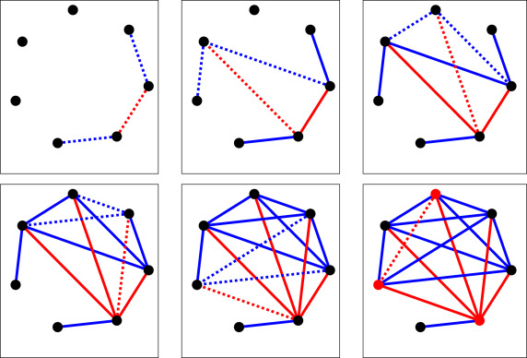
Fig. 1. A (7,2)-Triangle game. Maker-edges are red and Breaker-edges are Blue.

Literature review

In their seminar paper on positional games [2], Chvátal and Erdős proved that in the game on complete graphs, Maker has the winning strategy if q < √(2n + 2) – 5/2 ≈ 1.414√n, and if q ≥ 2√n, then the Breaker has a winning strategy. After that the problem of finding the exact leading constant became a matter of interest among the mathematicians.
Balogh and Samotji [3] slightly improved the constant given by Chvátal and Erdős for Breaker’s winning strategy from 2 to 1.935 using a randomized approach.

Glazik and Srivastav [1] presented a new deterministic strategy for Breaker’s win whenever n is sufficiently large and q ≥√ (8/3 + o(1))n ≈ 1.633√ n, significantly reducing the gap towards the lower bound. In previous strategies [3] Breaker chooses his edges such that one node is part of the last edge chosen by Maker, whereas the remaining nodes are chosen more or less arbitrarily. In contrast, Glazik and Srivastav introduced a suitable potential function on the set of nodes. This allows Breaker to pick edges that connect the most ‘dangerous’ nodes. The total potential of the game may still increase, even for several turns, but finally Breaker’s strategy prevents the total potential of the game from exceeding a critical level and leads to Breaker’s win. They defined the dangerous nodes as those that already have many incident Maker edges rather few Breaker edge.

BREAKER’S STRATEGY DEVELOPMENT
Some salient points for development of Breaker’s strategy are as under-
- The Breaker should first check if any loop of the maker is just one edge away i.e. if any of the path is of length 2. If this situation holds true, Breaker should claim that edge.
- If there is no loop for the Maker which is just one edge away, Breaker should claim the edge originating from one of the maker’s nodes.
- Breaker’s strategy came out as Breaker should select the edges with one of the nodes having comparativly more of the Maker’s edges than the others and containing less number of edges that are already selected by the Breaker. But this should be considered secondary to the first point.
- Maker can win by fixing a node v & then simply claiming all his edges incident to v. At some point, the Breaker will not be able to close all Maker’s paths of length 2 and that’s why the variable q plays an important role to make this game worthy. Breaker can always close all the paths of length 2 made by the maker & at the same time prevent maker to build a star of size q/2.
So, the only chance for maker to win the game is to construct more than q paths of length 2 as otherwise Breaker has a strategy to stop him. If maker claim an edge say {x,y}. Then the total paths of length 2 would be deg_{M}(x) + deg_{M}(y). And all these paths are required to be closed by the Breaker.
By considering these factors, we made multiple observations by varying the variables ‘n’ and ‘q’ of the (n,q)-Triangle game for the graph K_{n}. It was ensured to not make any dumb choice. The definition of dumb choice would be as follows-
When there is a clear opportunity in front of the player to either make the triangle (in the case of maker) or to close the way in the formation of the triangle (in the case of the breaker) but then also the player chooses to select some other arbitrary edge instead of claiming the useful edge for him, giving a total advantage to the opponent.

Simulator

To make this game more interactive and handier to play, we have made a Web Application to play this game. There are two modes in which one may play it, first one is by selecting the nodes to form the triangle. Maker will be given the chance to start the game by selecting the first node followed by Breaker selecting the q successive nodes. As soon as Maker has three nodes claimed by him, he wins the game by forming the triangle. On the other hand, Breaker in his chances has the goal of selecting as many nodes as he can so that before Maker gets the third chance, he has already selected all the free nodes of the graph. This “Node” mode of this game is not much of logical thinking but provides the idea about the ‘q’ chances given to the Breaker. If the value of ‘q’ is large enough that Breaker can claim all nodes before forming the triangle, then it’s Breaker’s win. On the other hand, if the value of ‘q’ is not sufficient to claim all the free nodes before maker gets the opportunity to claim the third node, then it’s Maker’s win. So, this mode is giving us the idea about advantage Breaker gets with the value of ‘q’ which is going to be an important factor in the second mode i.e., the edge mode.

In the edge mode, the rules are the ones which are mentioned in the II & IV section of the paper. And this mode is the main motive of making this game as by playing, it gives the logical understanding to the player and makes to apply this thinking by selecting the edges in such a manner that he can overplay his opponent.

In the Web Application, players are given the right to select the number of nodes with which they want to play the game. Say, if players select ‘n’ number of nodes then they can play the game in Nodes mode with n nodes and in Edges Mode with n*(n-1)/2 edges. After selecting the nodes, players can select the mode they want to play the game with, either Node or Edges. Also, players can select the number of moves ‘q’ that should be given to the Breaker in each chance. When these selections are made by the players then the game starts with a complete graph generating and chances given to both the players in respective manner.

The flow of game is represented in Fig. 2. with the case of node choice when after claiming the 3 nodes, Maker wins the game. But if before Maker claiming the 3 nodes, all the available nodes get exhausted, Breaker wins the game.

On the other hand, in Fig. 3. With the case of edge choice, the maker will have to make the loop by selecting the edges in such a manner that it will form the triangle to win the game. But if before Maker making any triangle, all the available edges get exhausted, Breaker wins the game.

The flow chart is going to remain same in both the cases, whether human-human game or human-computer game.
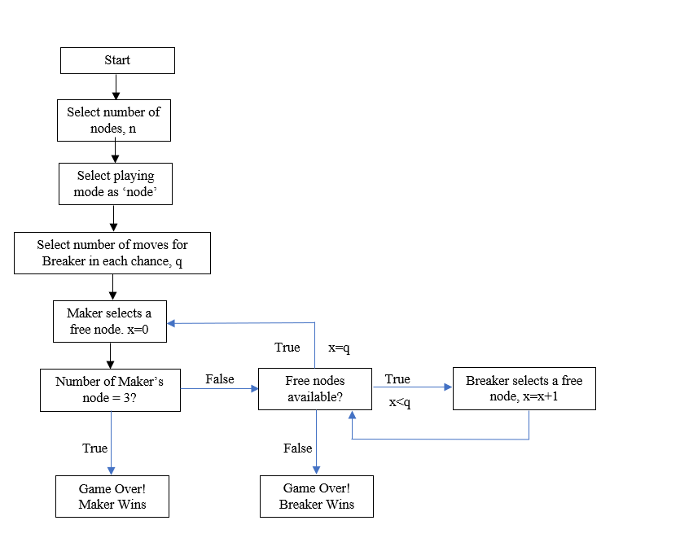
Fig. 2. Flow chart representing the Maker-Breaker Game in the ‘node’ mode of simulator.
`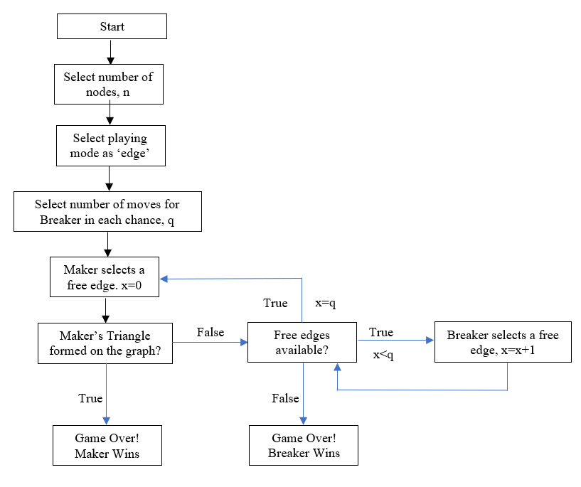 Fig. 3. Flow chart representing the Maker-Breaker Game in the ‘edge’ mode of simulator.

This game also contains the feature in which the player plays aginst the computer. In this situation, the human player is the Maker and the Computer acts like the Breaker.
For computer to play Breaker, it follows the rules defined in the earlier section. This increases the overall utility of the game by stopping the maker from making the triangle in a better way then by another human who might commit wrong moves.
If Maker manages to build a path (a, b, c) of length 2, Then we can he he is just edge away from winning. Hence Breaker is forced to close this path by claiming edge (a, c) if it is free.

Example of Simulation of the game-

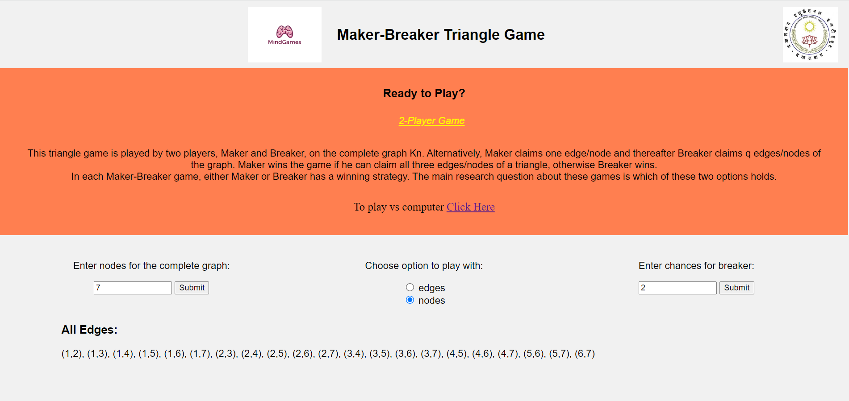
Fig. 4 . User interface of two player Maker-Breaker Triangle Game Simulator with options to select n(7), mode of play and q(2).

Node choice:

This is the example of Maker-Breaker Triangle Game simulator in the mode of ‘nodes’ with each maker & Breaker claiming the nodes of the graph K_{n} in each turn. As soon as Maker claims 3 nodes, he wins the game. So only ‘q’ is the variable on which the winning chances are dependent in this mode of the game. If q is sufficient enough to claim all edges before Maker claiming 3 edges, Breaker wins the game.
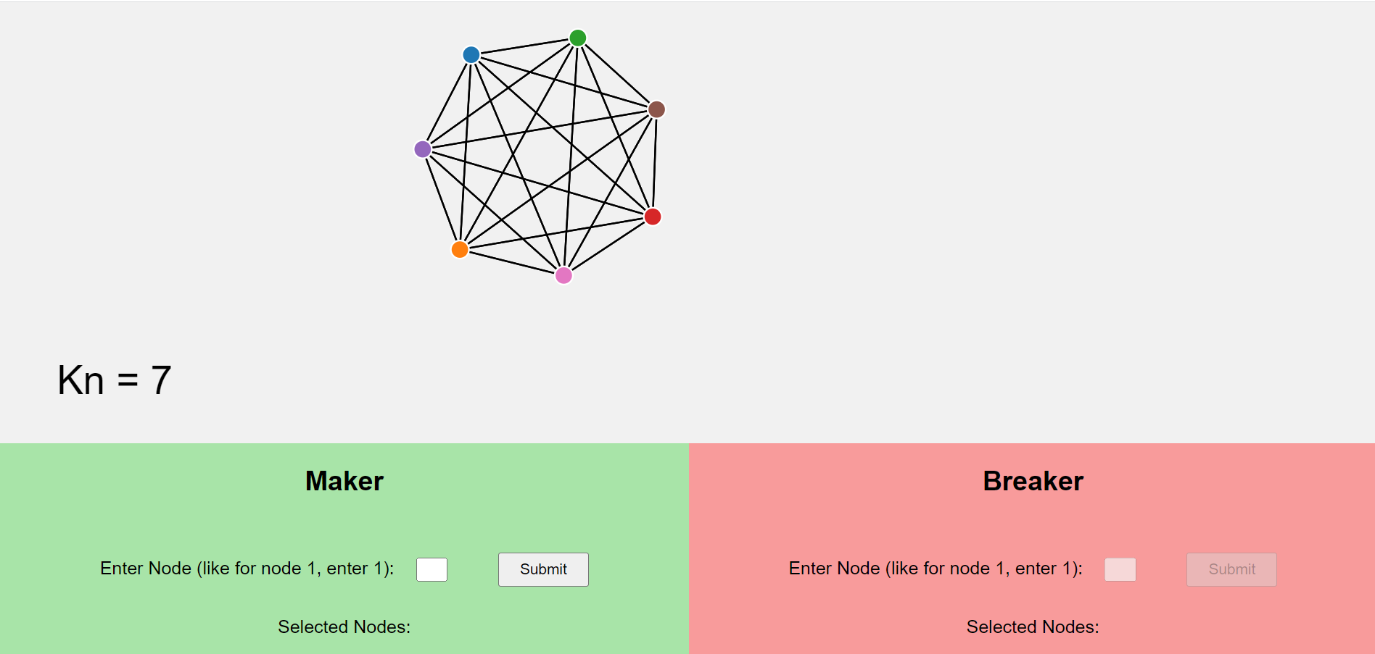
Fig. 5. Fields for Maker and Breaker to make their choices

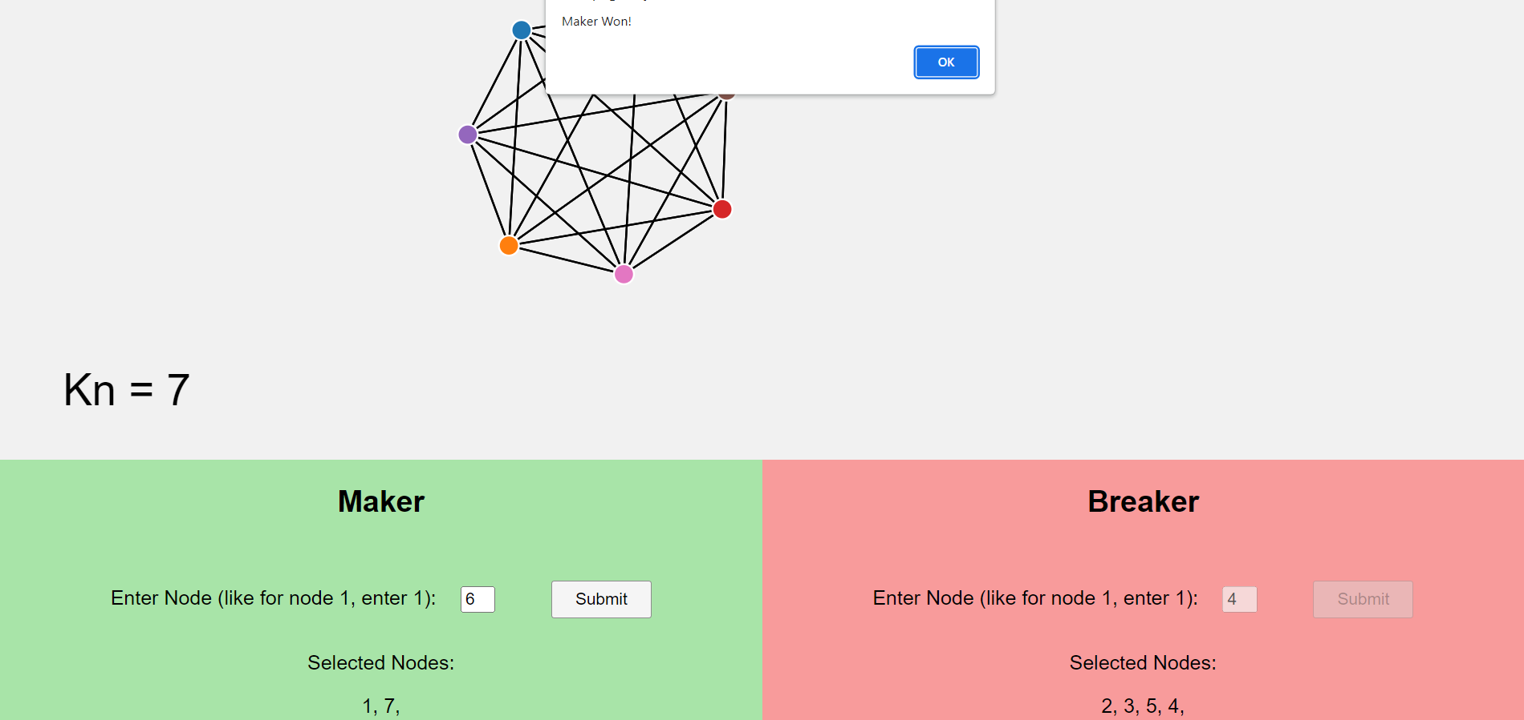
Fig. 6. Maker winning the game after making the final move and selecting node 6 completing 3 nodes of the triangle.

Edge choice:

Case 1: n=7 & q=2
Here, the players select the edges. Maker has 1 chance and value of q for Breaker can be selected from the input box as described in Fig. 4.
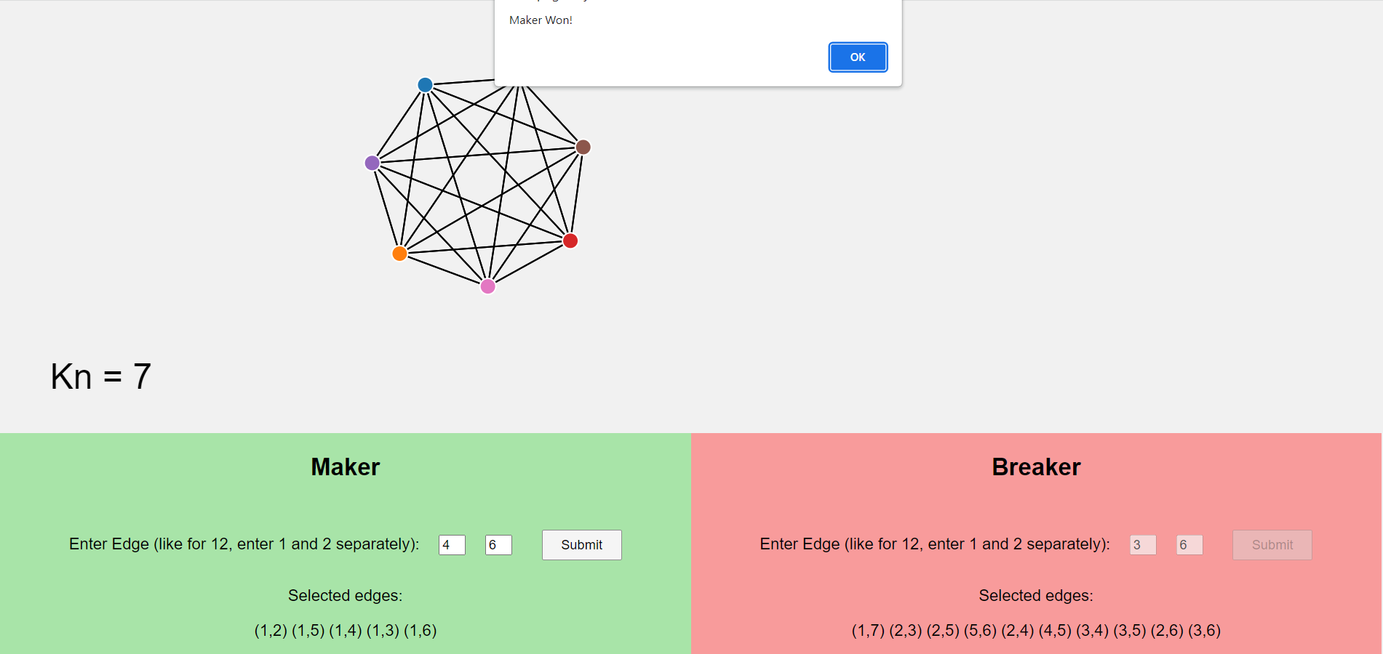
Fig. 7. Maker winning the edge-wise game of (7,2) after making the final move and selecting node 3 edges {(1,4),(1,6),(4,6)} of the triangle.

In the edge choice game depicted in Fig. 7. There are 7 nodes and 2 moves per chance for the Breaker. Maker started his move by selecting (1,2) edge of the graph followed by Breaker selecting (1,7) and (2,3) as two of his edges following the rule that Breaker edge should originate from the node already having more of Maker's edges. After that Maker selects (1,5) as his edge by following the rule that maker should select one node u and then select the edges by taking different values of v to make a bigger star.
Now, with (1,2) and (1,5) as selected by the maker so maker is just one edge away from making the triangle and that edge is (2,5). Now since Breaker has to religiously follow the foremost rule of closing paths of length 2 and hence he selects (2,5) and breaks a 2 length path of the Maker followed by selecting (5,6).
Continuing the game, Maker selects (1,4) making two paths of length 2. So to close them, Breaker selects (2,4) and (4,5).
Maker has to hustle again to create paths of length 2 so he selects (1,3) which yet again makes two paths of length 2 and Breaker closes them by selecting (3,4) and (3,5).
Maker now selects (1,6) and this time he makes three paths of length 2 with unclaimed nodes as (2,6), (3,6) and (4,6) achieving his goal of making more than 'q' paths of length 2 for himself.
This comes out to be a losing situation for the Breaker as from these edges, Breaker selects (2,6) and (3,6) as his edges to close two paths of length 2 which is the most he can do and in the next move Maker selects (4,6) making a triangle as (1,4), (1,6) and (4,6). And hence, Maker Wins!
All the moves in this scenerio are made by considering the Breaker’s strategy described in the IV section of the game. We can see that Maker fixed a node as 1 and then selected the other nodes to make the choice for his edge. This way he can make a bigger star and try to achieve more than q paths of length 2. On the other hand Breaker was closing all the available paths of length 2 in each chance followed by selecting edges with nodes having more of Maker’s edges to stop the Maker from making a bigger star.
Case 2: n=7 & q=3
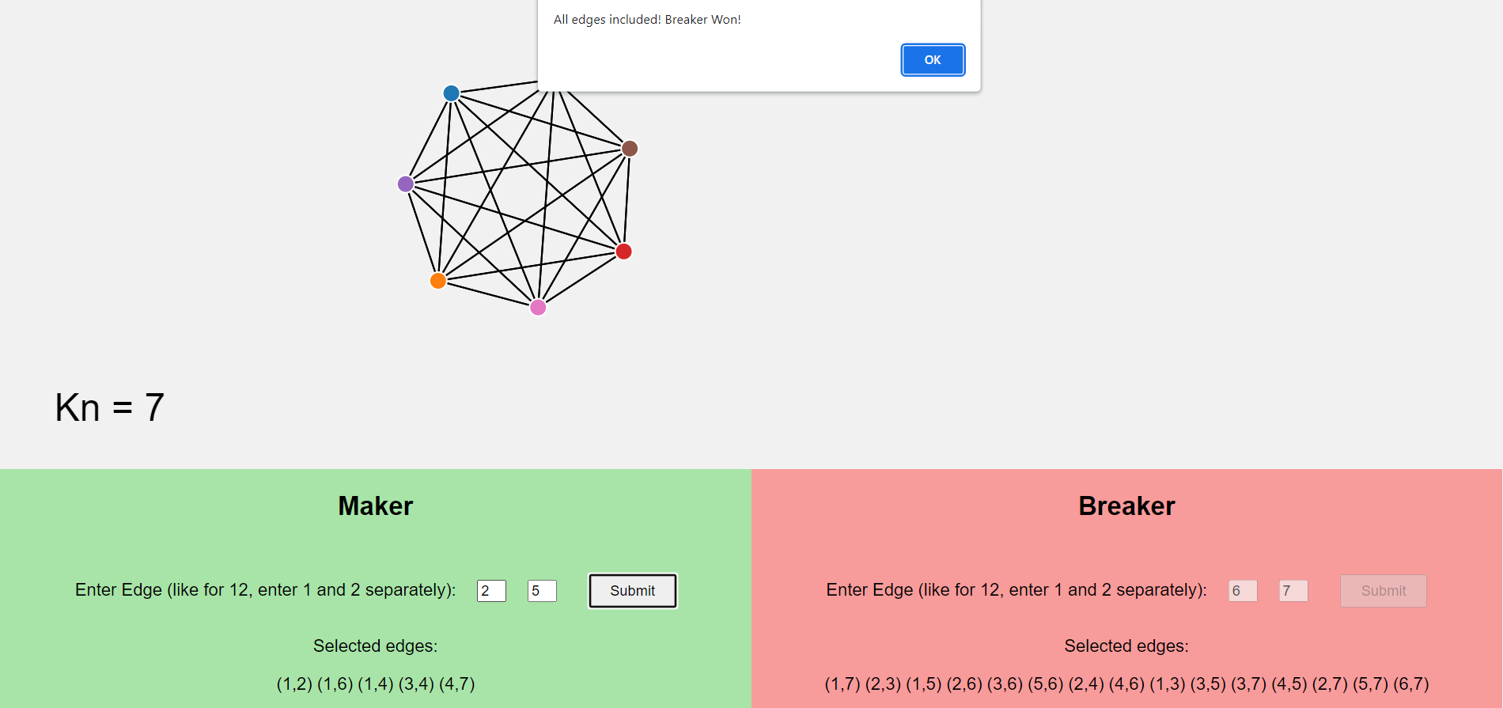
Fig. 8. Breaker winning the edge-wise game of (7,3) after blocking all the length 2 paths of maker and exhausting all the edges of the graph.

In this case the moves given to Breaker are significant enough, which is 3, to stop the maker from making a triangle in the K₇ graph. Since all the edges are exhausted before Maker claiming a triangle, hence in this case Breaker Wins!
So, we saw that for q<=2 it’s a winning strategy for the Maker but once the value of q exceeds 2, there is going to be a winning strategy for the Breaker.
The scope of this game is further extended by varying some rules in order to make the players think differently and making correlation between the different variations of the game. Like, instead of having a complete graph, we have given an option to make a graph consisting of only x% of the edges making the game a little biased. As the graph keeps getting sparse, the strategy will also vary depending on the position of the edges. Edges could be more densely populated in the one region of the graph than the other or maybe equally distributed. The ratio of edges in one region and the other will impact the players choices by selecting edges more in the region with more number of edges as that’ll be providing more winning chances than making selections in the region with less number of edges. The simulator provides all these options for better engagement and development of intuition.

DISCUSSION AND RESULTS
The Two-player game and the Computer-Human game both are implemented in the web application with the defined rules enabling the players to understand the game thoroughly about the region of uncertainty in the choice of q. After the efforts of Christian Glazik and Anand Srivastav the region of uncertainty for the value of q has been reduced. For q ≥√ (8/3 + o(1))n ≈ 1.633√ n, there is going to be a winning strategy for the Breaker and for q < 1.414 √n, Maker has a winning strategy. But finding a leading constant is still an open question.

The Web Application implemented by us is a good platform to play the game and think about the heuristics to enhance the efficiency of selections to be made by either Maker or the Breaker. Right now the scope of this game, in context of complete graph, is more or less enough in the case of two-player game with the two independent players playing the game but in the case of Computer-Human the algorithm followed can be improved to make a winning strategy for the Breaker with least possible value of ‘q’. As the size of the graph increases, it will be difficult for the Breaker to prevent the Maker from making stars of size at least q/2 or preventing him from making more than ‘q’ paths of length 2 in a particular turn. It is also useful as a pedagogical tool to enable algorithm designers for graph problems to develop better intuition.

Acknowledgment
We would like to thank Prof. Anand Srivastav for brining our attention towards this interesting game and the question around it.

References

[1] Christian Glazik and Anand Srivastav, A new Bound for the Maker-Breaker Triangle Game. Dec, 2018. URL: https://arxiv.org/abs/1812.01382

[2] V. CHVÅTAL and P. ERDÖS, Biased Positional Games. 1978. URL: https://www.link.cs.cmu.edu/15859s11/notes/posgame.pdf.

[3] József Balogh and Wojciech Samotij, On the Chvátal-Erdős Triangle Game. 2011. URL: https://www.combinatorics.org/ojs/index.php/eljc/article/view/v18i1p72

[4] Andrew Beveridge, Andrzej Dudek, Alan Frieze, Tobias Muller and Milos Stojakovic, Maker-Breaker games on random geometric graphs. 2014. URL: https://kilthub.cmu.edu/articles/journal_contribution/Maker-Breaker_games_on_random_geometric_graphs/6478268

[5] Fran Blumberg, Kirby Deater-Deckard, Sandra L Calvert and Rachel M. Flynn, Digital Games as a Context for Children's Cognitive Development: Research Recommendations and Policy Considerations. Feb, 2019. URL: https://www.researchgate.net/publication/ Digital_Games_as_a_Context_for_Children's_Cognitive_Development_Research_Recommendations_and_Policy_Considerations

[6] Han L J van der Maas and Enkhbold Nyamsuren, Cognitive Analysis of Educational Nov, 2016. URL: https://www.researchgate.net/publication/310602744_Cognitive_Analysis_of_Educational_Games_The_Number_Game

